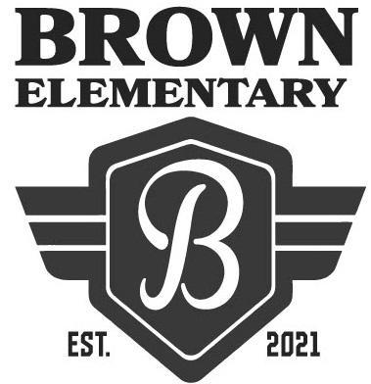
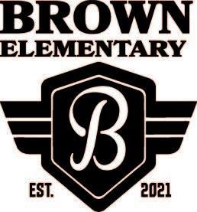
Welcome to Hannah Marie Brown Elementary School!
The first day of school is Monday, August 9, 2021.
School hours are 7:50am to 2:11pm.
Suggested Supply List for Kindergarten Students – 2021/2022
The Clark County School District provides necessary supplies for all students in order to meet their educational needs. However, we know that sometimes parents choose to buy school supplies. Should you decide to do this, the following items are appropriate:

Optional Supplies for ALL KINDER teachers | Other Optional Supplies
- Standard size backpack (NO WHEELS)  - 2 boxes of kleenex  - Crayola crayons (24 count)  - 6 Jumbo glue sticks  - 8 Expo dry erase markers (thin black only)  - 1 pair of scissors | - 1 bottle of regular hand sanitizer  - 1 set of watercolor paints  - 1 package of standard play-doh  - 1 package of lysol wipes and/or baby wipes  - 1 box of gallon size bags (boys)  - 1 box sandwich bags (girls)  - 2 rolls paper towels  - 2 packs of magic erasers

