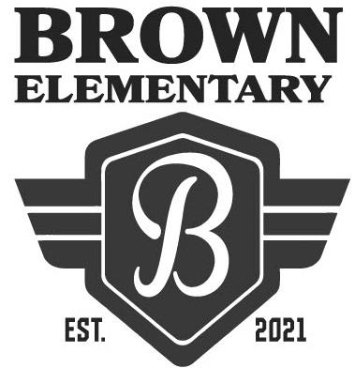
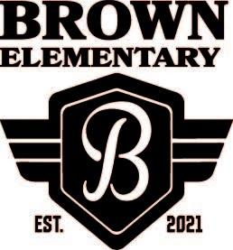
Welcome to Hannah Marie Brown Elementary School!
The first day of school is Monday, August 9, 2021.
School hours are 7:50am to 2:11pm.
Suggested Supply List for 2nd Grade Students – 2021/2022
The Clark County School District provides necessary supplies for all students in order to meet their educational needs. However, we know that sometimes parents choose to buy school supplies. Should you decide to do this, the following items are appropriate:

Supplies for ALL 2nd Grade Teachers
- 1 pencil box (standard size approx. 8”x5”)  - 1 pair FISKAR’S child size school scissors  - 2 pack Expo markers  - 2 pack highlighters  - 2 white erasers (not pencil top)  - 12-inch ruler with centimeters – flat, wooden or plastic, NON- BENDABLE  - 1 dozen sharpened #2 lead pencils – plain yellow, no designs (Ticonderoga preferred)  - 2 regular-size Glue Sticks  - 1 box Crayola crayons – 24 count  - 1 box of Kleenex (regular size)  - 1 container of cleaning wipes  - 1 bottle of hand sanitizer  - 1 wide ruled spiral notebook  - 2 plastic pocket folders blue and red  - A half inch (1/2) white 3-ring binder with clear sleeves on covers  - 1 pair of headphones (no earbuds or Bluetooth ones please)  - 1 box (10 count) thin Crayola markers (Ms. Treadaway’s class only)  *If your child is in Ms. Treadaway’s class, you do not need to provide headphones. | Optional items include:  - 1 ream of white paper  - 1 box of Ziploc quart freezer bags - girls  - 1 box of Ziploc gallon freezer bags – boys  Please adhere to the sizes listed as supplies are stored in shared containers and space is limited. Please leave all supplies in original boxes/containers and label your child’s backpack and supply box with your child’s name.  **We realize that following the circumstances of the past year , many families have dealt with financial issues. If you cannot send in supplies for your child, please contact your child’s teacher and he/she will make sure that your child has everything needed for the school year.

