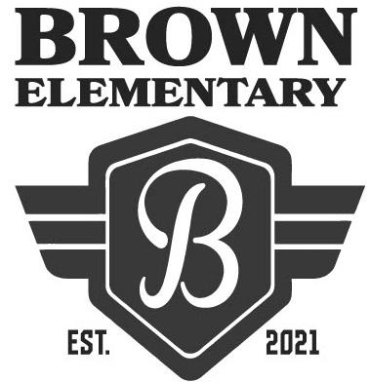**Welcome to Hannah Marie Brown Elementary School!**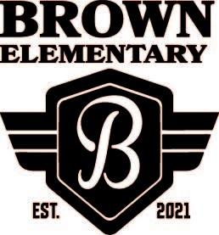

**The first day of school is Monday, August 9, 2021.**

**School hours are 7:50am to 2:11pm.**

**Suggested Supply List for 1st Grade Students – 2021/2022**

The Clark County School District provides necessary supplies for all students in order to meet their educational needs. However, we know that sometimes parents choose to buy school supplies. Should you decide to do this, the following items are appropriate:

|  |
| --- |
| Supplies for ALL 1st grade teachers |
| * Crayola crayons- 3 boxes, 24 count each * 8 Elmer's glue sticks * 1 pair FISKAR'S child size school scissors * 2 standard size pink erasers * 1 standard size pencil box, 8" x 5", no handles, no zippers, no locks * 2 packages yellow #2 soft pencils - (Ticonderoga brand preferred) * 1 pack Expo markers * 1 individual-sized plastic pencil sharpener * 1 white 1 inch ring binder   *Please adhere to the sizes listed as supplies are stored in each child’s desk and space is limited. Please leave all supplies in original boxes/containers and label your child’s backpack and supply box with your child’s name.  **\*Due to hygiene concerns, please provide 1 set of headphones with 3.5 mm plug compatible for computer headphone port for computer use. Please label with your child's name and place it in a one gallon Ziploc bag; also mark the baggie with your child's name.**  Other optional items include:   * 1 container wet wipes * 2 boxes of Kleenex (regular size) * 1 roll of 2-ply paper towels * 1 ream of white copy paper * 1 regular size backpack (daily use) without wheels * Ziploc baggies (gallon and quart sized) |