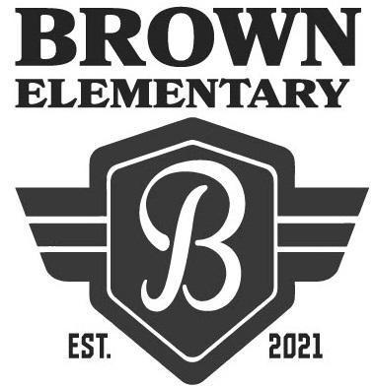
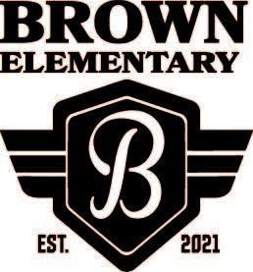
Welcome to Hannah Marie Brown Elementary School!
The first day of school is Monday, August 9, 2021.
School hours are 7:50am to 2:11pm.
Suggested Supply List for GATE 2021-2022
The Clark County School District provides necessary supplies for all students in order to meet their educational needs. However, we know that sometimes parents choose to buy school supplies. Should you decide to do this, the following items are appropriate:
Gate supply List
- 1 composition book
- 1 inch binder
- 1 pack of colored pencils
- 1 pack of pencils

